**Student Questions**

Learn about the internals of a standard PC case by examining physical samples and selecting and labeling images found on-line. Gain deeper knowledge by researching and reporting on specific components.

PC Tower Case

1. Find one (or more) images that clearly show the internals of a PC Tower Case.   
   (i.e. Google images using keywords “PC Case Internals”)
2. Clearly label the following components (using arrows) on your image of the PC case internals:
   1. Motherboard
   2. Power Supply
   3. Hard Disk Drive
   4. Optical Disk Drive (e.g.DVD)
   5. USB Expansion Ports
   6. Monitor Port
   7. Audio Ports
   8. Ethernet Port
   9. Cooling Fan
3. Research more in-depth about “Hard Disk Drives”. Make notes on the following:
   1. What different versions are currently available (speed and capacity)
   2. How the capacity of the component has changed since the 1980’s

* Currently there are many different types of hard drives such as ssd, Sata and Scsi. They all have different speeds ranking form ssd to sata to scsi, Sata is slower since it has actual moving parts which cannot move fast as the non moving parts in a ssd.

Back in the day storage capacities use to be way lower since the technologies were not as advanve, 100mb hdd use to be considered a big deal and now a days 500gb is below average and 5-10tb being the highest.

PC Motherboard

1. Find one (or more) images that clearly show the layout of a PC Motherboard.   
   (i.e. Google images using keywords “PC Motherboard”)
2. Clearly label the following components (using arrows) on your image of the PC motherboard:
   1. CPU (and fan)
   2. RAM Memory
   3. Disk Drive Interface (IDE or SATA)
   4. GPU Graphics Processor (either on-board or Graphics Card)
   5. Sound Processor (either on-board or Sound Card)
   6. Wi-Fi / Ethernet Network Interface (either on-board or Graphics Card) 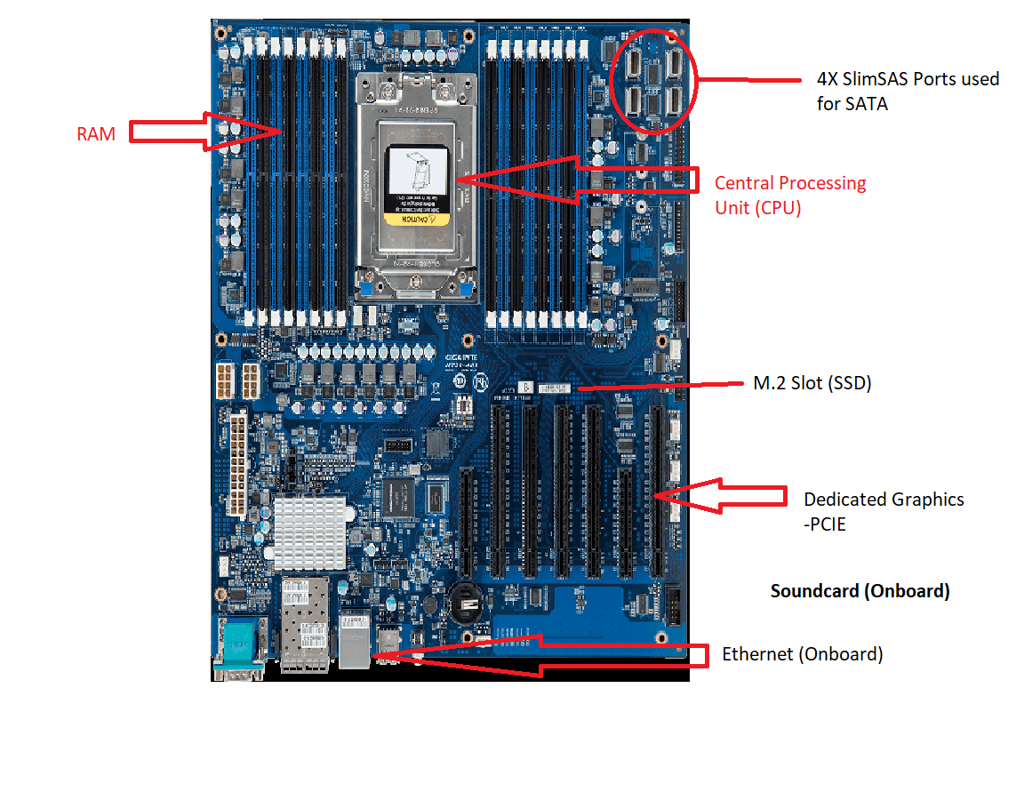

1. Research more in-depth about “CPU Processor Chip”. Make notes on the following:
2. What different versions are currently available (speed and capacity)
3. Proccesor chips have varying speeds and different kinds of core counts (6,8,16 etc depends on the price). On average cpu contains 4 cores with 3.4 Ghz But the more highend cpu’s have many cores and have 8ghz speeds
4. How the speed of the component has changed since the 1980’s
5. Before the 1980’s CPU’s only had only 1 core which ran at 6 Mhz which is realy low compared to today’s average 4ghz. In the 1990’s the speeds went up to 20mhz as technology advanced even more multi core processors came out and ever since then manufacterors have added more cores and upped the ghz.

Peripheral Devices

1. Find one (or more) images that clearly show the layout of the back of a typical PC tower case.   
   (i.e. Google images using keywords “Back Of PC Tower”)
2. Clearly label the following components (using arrows) on your image of the back of a typical PC tower case:
   1. Power cord and power switch
   2. Monitor Interface (VGA or DVI or HDMI)
   3. Mouse Interface (USB or PS/2)
   4. Keyboard Interface (USB or PS/2)
   5. USB Ports
   6. Audio Inputs / Outputs
   7. Ethernet Interface

1. Research more in-depth about “External Portable Storage”. Make notes on the following:
2. Floppy Disks

Basically a plastic slim box that is used to store data essentially a big usb.  widely used to distribute software, transfer files, and create back-up copies of data. When hard drives were still very expensive

1. CD-ROM / DVD / Recordable CD/DVD

A circle disk that is used to stores photos,videos and programs, and can hold up to a maximum of 700mb.  CD works by focusing a 780 nanometer wavelength semiconductor laser onto a single track of the disc.

1. USB Memory Drives

are often used for storage, data back-up and transfer of computer files. How the USB workds is that the flash drives draw power from the computer via the USB connection and transfers files

**Compact Flash Memory**

Memory storing technology to store data on a very small portable device

1. Cloud Based Storage  
   **Cloud computing technology** allows people to use the digital resources stored in the virtual space by way of networks. And it allows themto store there data in the cloud.